**Car claim Insurance Case Study**

**A car insurance policy is a mandatory requirement as prescribed by the Motor Vehicles Act, 1988. That is why every car driving on Indian roads carries a valid insurance cover. This cover comes in handy in times of any contingency involving the car. In case of accidents or facing car related damages, a claim arises in the car insurance policy**

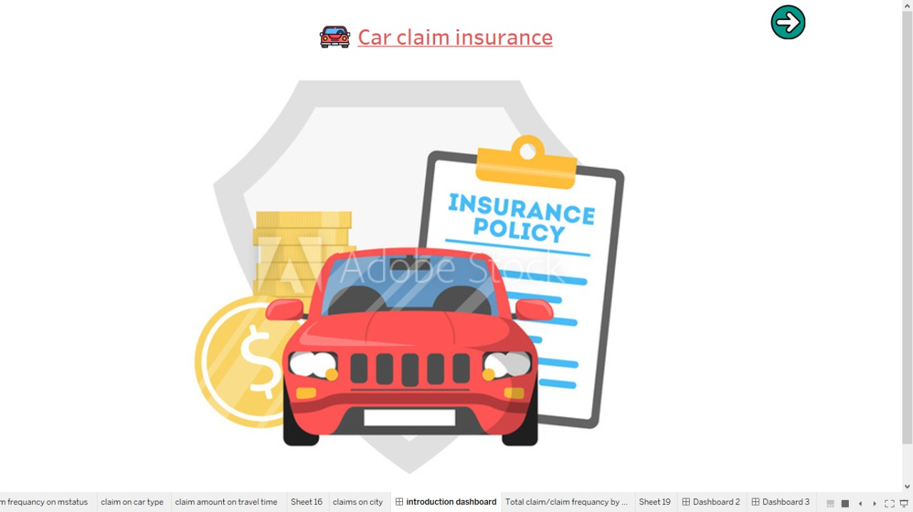

**The challenge-:**

**The IT department used standard tools like Excel and SQL Server for data analytics and reporting.** **It is difficult and its create a problem in excel if we use a large data set that's why we use Tableau to minimize the difficulties and for smooth working.** **With Tableau, time spent on creating reports is much lesser than creating reports manually. Teams were able to deliver reports much faster, sometimes even reporting on daily or hourly basis.**

#### Implementation-:

#### The executives introduced Tableau in Car Insurance India as a means to analyze and govern data on a selected set of business use cases and scenarios to help in decision making. But sooner than they realized, Tableau became an integral part of the company’s functioning. The company experienced a cultural shift where the approach to business and growth was more data-centric and data-driven.

#### Visualization-:

#### On the basis of different categories we can create different visual and different dashboard for sales and insurance.

#### Types of data visualization we use

* **Column Chart.**
* **Bar Graph.**
* **Stacked Bar Graph.**
* **Line Graph.**
* **Dual-Axis Chart.**
* **Mekko Chart.**
* **Pie Chart.**
* **Scatter Plot.**

#### Butterflay Chart

#### *Conclusion-:*

**From the Insurer's Perspective**

**1) Individuals driving Panel and Van vehicles are least likely to take insurance claims.**

**2) Individuals living in highly rural and rural areas are a better bet for insurance. however the income disparity is higher, which may provide less data for rural population and leads to this conclusion.**

**3) The Claim Amount and Frequency is lower in Commercial Use and the same can be a parameter to provide insurance.**

**4) The Claim Amount and Frequency is lesser in Males and the same can be a parameter to provide insurance and thourough vetting of documents and driving skills.**

**5) The Claim Amount and Frequency is in the region of 24-37 hours worth of travel time across both the commercial and private use. Less and More than these number of hours the data fades. Major accidents may be caused due to lack of sleep and tiredness.**

**6) The Claim Freq. is greater for married individuals as compared to non married individuals. However, the contrary is true for Claim Amount. which means that married status is not a true indicator for the same.**

**7) Car age does not have a continuous relation to claim amount and Claim Freq. However, with greater car age the amount and frequency have decreased which means wither the cars have stopped getting insured or the drivers have learner from expierience. which can be supplemented by 1st Year claim amount and Feequency.**

**8) People with PhDs as education and Doctors by profession have least frequency and amount for claims.**

**Thank You**